Grade 2 Home Learning Activities – Week 3
Choose one item from each learning area a day. Check off as many as you can!
Grade 2 Learning Areas | M | T | W | Th | F
French reading ideas for the week: Read-to-self 15 minutes, Read-aloud 15 minutes
- Raz Kids – https://www.raz-kids.com/main/BookDetail/id/1377
- Epic Books - https://www.getepic.com/educators
- Home material – read your books at home!
- High-frequency words – Les mots fréquents - Practice reading and spelling them. Added challenge: use them in a sentence orally or in writing. Find links to them on our website under French Literacy www.grade2SES.weebly.com
NON INTERNET ACTIVITIES
You or another family member can read to your child in French (if possible) or English.
Children could read a book independently or choose to read it to a family member, stuffed animal, or pet.
French Writing Ideas for the week: Healthy Habits
See pages 2 & 3 for theme specific vocabulary and ideas of how to create a list.
- Create a list of personal healthy habits
- Write about daily routine. Include personal healthy habits (ie: brush teeth, wash hands, etc.)
Try to write 5-7 sentences. Use a beginning sentence (ie: My name is _____. Every morning, I wake up around eight o’clock.) and a wrap up sentence (ie: What is your daily routine?) Include details, punctuation, finger spaces and no excuse spelling words (les mots fréquents) spelled correctly!
Math ideas for the week: See our grade-level website for additional ways to do these activities in French; however, maintaining these skills in English will support math learning in French going forward.
- Skip-counting sequences (2-A.2)
https://ca.ixl.com/standards/new-brunswick/math/grade-2
- Identify numbers as even or odd (2-A.7)
https://ca.ixl.com/standards/new-brunswick/math/grade-2
- Addition and Subtraction Facts: “Math Stack”
https://www.abcya.com/games/math_stack
NON INTERNET ACTIVITIES
Play card games (crazy eights, go fish), Count the number of steps as you walk, Have your child count objects (up to 100), Write or make a drawing showing what they counted & how they counted (by 2,5,10), Count how many of each object found during Art activity (see below) & add together
Free play: Have fun doing whatever you love to play.
Challenge: Enjoy your playtime without ANY screens for 1 hour!
Art: Name Writing Nature Hunt – See an example on page 4
Create a list of items to look for outside (ie: twigs, bark, pebbles, dirt, etc). After finding the list of items, spell out your name (on grass, driveway, deck)!
Suggestion: Try spelling high-frequency words as well!
Physical Education/Mindfulness: Daily Physical Activity
- Physical Activity: Enjoy the great outdoors and play outside!
- Raining out? Enjoy dancing inside (select playlist: Pauses Actives - WIXX) – https://www.youtube.com/user/WixxTV/playlists
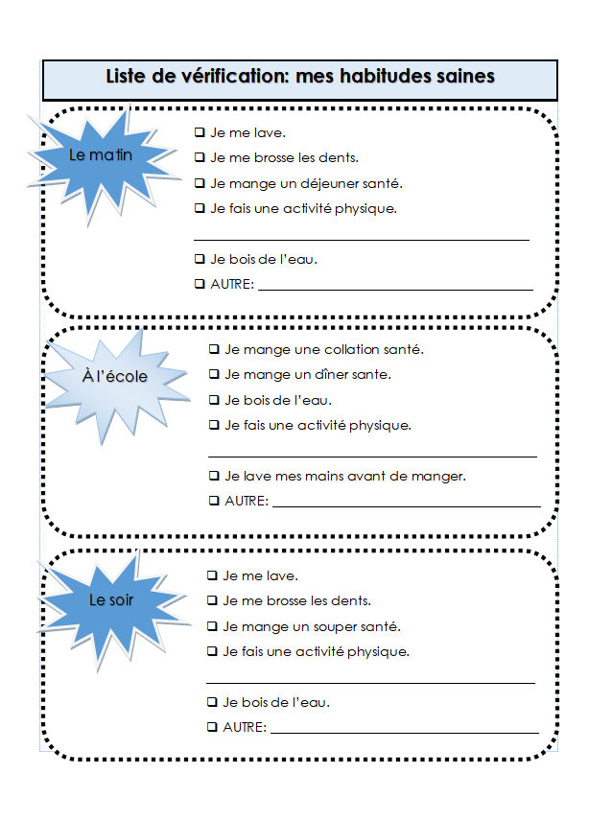
Je suis en bonne santé
Que fais-tu pour être en bonne santé?
Pour être en bonne santé, je ___________.

- fais de l’exercice tous les jours
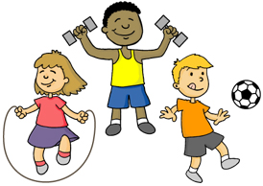

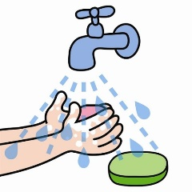
- me lave les mains avant de manger

- mange un bon déjeuner
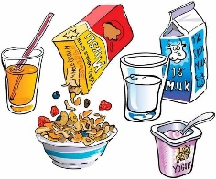

- mange un bon repas

