Grade 2 Home Learning Activities –Week 2
Choose one item from each learning area a day. Check off as many as you can!
Grade 2 Learning Areas | M | T | W | Th | F
French reading ideas for the week: Read 15 minutes a day
- Raz Kids – https://www.raz-kids.com/main/BookDetail/id/1377
- Epic Books - https://www.getepic.com/educators
- Home material – read your books at home!
- High-frequency words – Les mots fréquents - Practice reading and spelling them. Added challenge: use them in a sentence orally or in writing. Find links to them on our website under French Literacy www.grade2SES.weebly.com

NON INTERNET ACTIVITIES
You or another family member can read to your child in French (if possible) or English.
Children could read a book independently or choose to read it to a family member, stuffed animal, or pet.
French Writing Ideas for the week: Spring theme
See final page for a related piece of reading to help with writing and theme specific vocabulary.
- If you were a butterfly what color(s) would you be? How old would you be as you are writing? How would your life transform?
Try to write 5-7 sentences. Use a beginning sentence (ie: If I were a butterfly I would be many beautiful colors!) and a wrap up sentence (ie: Where would you live?) Include details, punctuation, finger spaces and no excuse spelling words spelled correctly!

Math ideas for the week: See our grade-level website for additional ways to do these activities in French; however, maintaining these skills in English will support math learning in French going forward.
- Skip-counting (2-A.1)
https://ca.ixl.com/standards/new-brunswick/math/grade-2
- Addition Facts to 18
https://www.abcya.com/games/math_facts_game
- Even and Odd Review
https://ca.ixl.com/standards/new-brunswick/math/grade-2 Even or odd (2-A.6)

NON INTERNET ACTIVITIES
Play card games (crazy eights, go fish), Count the number of steps as you walk, Have your child count objects (up to 100) write or make a drawing showing what they counted and how they counted (by 2,5,10)
Free play: Have fun doing whatever you love to play. Challenge: Enjoy your playtime without ANY screens for 1 hour!

Art: Enjoy learning how to draw or paint spring pictures!
Visit Art Hub for some great ideas! https://www.artforkidshub.com/seasons/spring/

Physical Education/Mindfulness: Daily Physical Activity
- Physical Activity Enjoy the great outdoors and play outside!
- Raining out? Enjoy some yoga – https://www.youtube.com/user/CosmicKidsYoga
Le printemps

Le cycle de la vie :

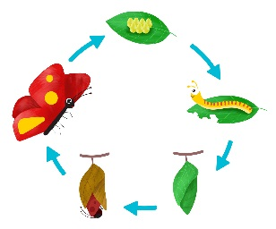

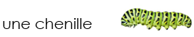

grandit

se transforme

Quel âge as-tu? J’ai 8 ans.
