Grade 2 Home Learning Activities –Week of April 6-10
Dear Families,
Our Grade 2 team has developed a home-learning guide to assist with the literacy and numeracy outcomes for the remainder of the school year.
The Department of Education and Early Childhood Development (EECD) has recommended families:
- read-aloud to their children daily;
- support their children to complete reading, writing and numeracy activities for an average of 1 hour per day;
- consider daily physical activity and free play as important parts of their child’s mental health and skill development.
As your child’s teachers, we are here to support you and your child in their learning. If you have any questions, please email your child’s teacher. We will send out new activities and resources weekly. We’re in this together. Keep in touch to let us what is working and what is not. We can adapt as necessary. Enjoy learning together.
Grade 2 Learning Areas | Monday | Tuesday | Wednesday | Thursday | Friday
French Literacy:
Read-to-self 15 minutes a day. Listen to a read-aloud for 15 minutes.
Storybooks ( Choose French) – https://www.storybookscanada.ca/stories/fr/
Story Weaver - https://storyweaver.org.in/search?query=french
Home material – read your books at home. – Parents can read aloud in English or French if possible
Listening in French-https://bibliotheques.sherbrooke.ca/contes-en-ligne
Mots fréquents and French sounds: To learn you sounds and French words you can go to the YouTube channel of Ruth Mclaughlin (ASD-S grade two FI teacher.)
https://www.youtube.com/channel/UCoisVPkPo4o1TKNMQgU25DQ/playlists?fbclid=IwAR3EBWYF3qqaP_RFDZXeMAfXKuxVl_99Jh8mtx9Z1HWWCM2_iqeJvbbqdFE
Writing
Easter is here. Write to the Easter Bunny. You can use your high-frequency words (mots fréquents), Easter vocabulary words (attached below) and you can sound out words you do not know.
Try to write 5-7 sentences in less than 30 minutes.
Star Writers can: 1. Use finger spaces. 2. Use punctuation. 3. Use an uppercase letter at the beginning of each sentence. Use the word wall and sight words. Think- tell me something, tell me more make a comment or tell more.
Math – Doing these activities in French helps language development. Doing them in English also has great value in maintaining math skills and knowledge.
- Skip counting ixl
Skip-counting (2-A.1)
https://ca.ixl.com/standards/new-brunswick/math/grade-2
- Addition Facts to 18
https://www.abcya.com/games/math_facts_game
- Even and Odd Review
https://ca.ixl.com/standards/new-brunswick/math/grade-2
Even or odd (2-A.6)

Free Play- have fun doing whatever you love to play. Enjoy your playtime! Take what you have learned and see if you can use it when you are playing!

Art
Enjoy learning how to draw or paint Easter pictures. I would love to see your Easter Art! Visit Art Hub for some great ideas! If you can, e-mail me the pictures.
https://www.youtube.com/results?search_query=art+hub+for+kids+easter
or
https://www.youtube.com/watch?v=mMhnHdHDyGo (French)
Daily Physical Activity
- Enjoy the great outdoors and play outside!
- Raining too hard out? Enjoy some yoga - https://www.youtube.com/results?search_query=cosmic+yogas
- You can also follow the April calendar of physical activities to do. Keep active!

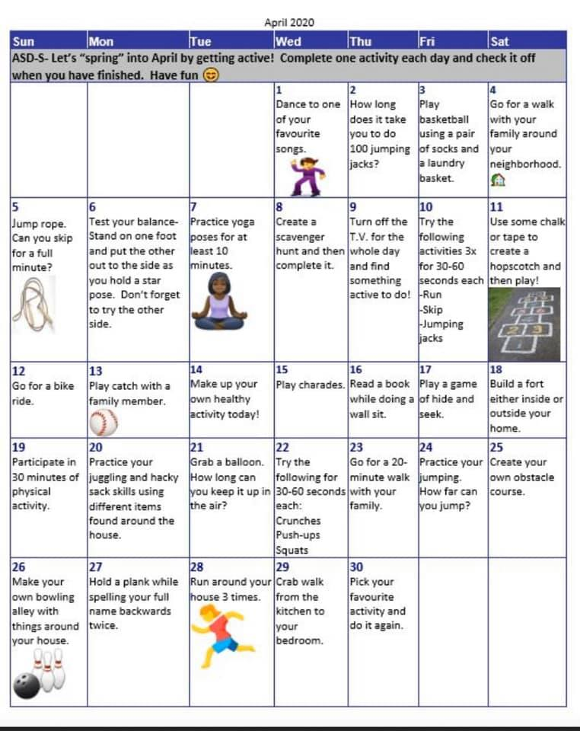

VOCABULAIRE DE Pâques ( Easter VOCABULARY IN FRENCH)
Lapin 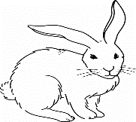 chocolat 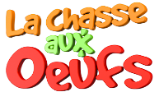
oeufs de Pâques

Fleurs jonquilles 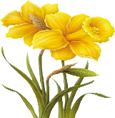 tulipes

Couleurs : rose, jaune, bleu, vert, orange , violet, rouge, brun

